Updated: September 2021

Arthropod
Collection Traps


Project Supplement

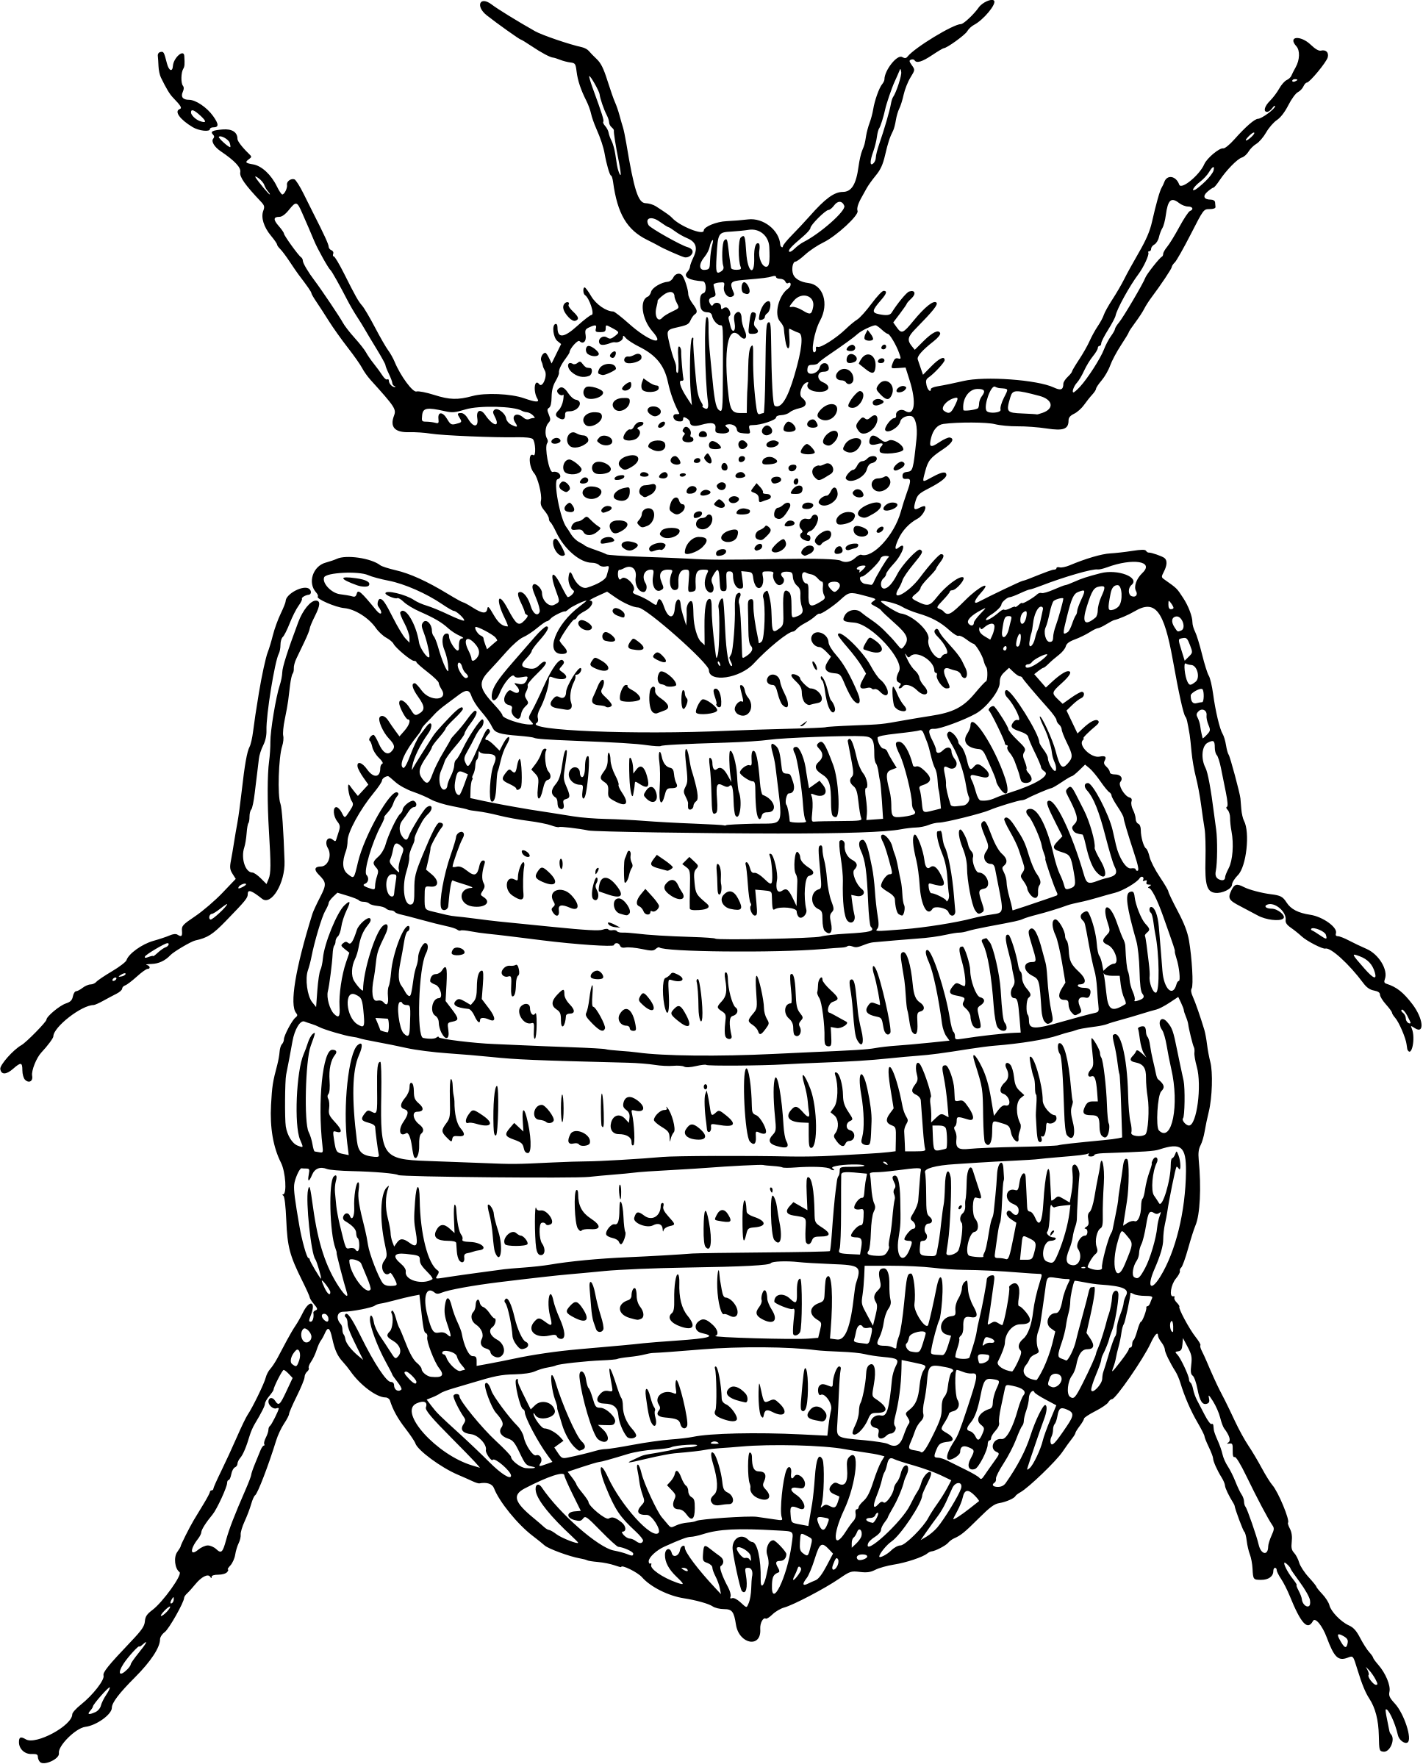

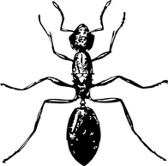
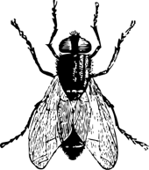
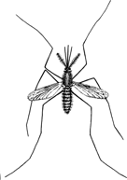
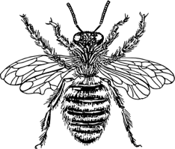
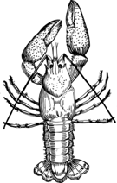

Table of Contents

Page | Contents
3 | Introduction
4 | Mosquito Traps
5 | Brown Sugar & Yeast Trap
6 | Flying Insect Trap

Content is made available under the Creative Commons Attribution-NonCommercial-No Derivatives International License. Contact (wolbachiaproject@vanderbilt.edu) if you would like to make adaptations for distribution beyond the classroom.



The Wolbachia Project: Discover the Microbes Within! was developed by a collaboration of scientists, educators, and outreach specialists. It is directed by the Bordenstein Lab at Vanderbilt University.
https://www.vanderbilt.edu/wolbachiaproject

Video Guides available at:
https://youtube.com/playlist?list=PLDke7FEFQMhoXB_K-fE2GHzsVrao3DdWz

Contributions by:
Alex Shen, Vanderbilt University

Introduction

Before beginning The Wolbachia Project, you will need to:
- Identify specific arthropods that address your hypothesis or experimental goals
- Select the best methods for collecting each arthropod

If your experiment explores the frequency of Wolbachia infections between two native species of mosquitoes in the community, for example, you will have more success with a collection method that is specific to mosquitoes and flying insects rather than leaf litter beetles. You may also wish to select for a certain developmental stage, such as larvae vs. adults, or preferentially collect a specific mosquito species.
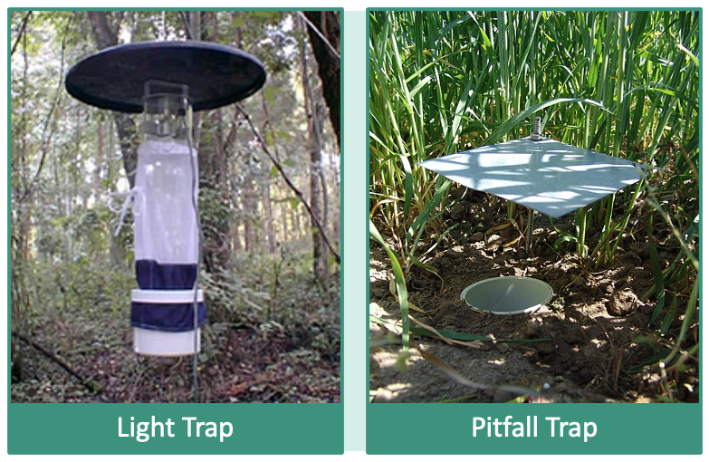

Figure 1. Carbon dioxide-baited light traps are designed to attract and collect mosquitoes whereas pitfall traps will collect ground-dwelling arthropods and other small animals. Light trap image is available by the National Park Service on Wikipedia. Pitfall trap image is available by Mnolf via a CC-BY-SA-3.0 license on Wikipedia.

A thorough experimental design should guide your arthropod collection. When preparing the collection protocol(s), consider the following questions:
- List your target arthropods. Do you need a specific life stage?
- Where do they live? Are they flying, terrestrial, aquatic?
- Are they seasonal? Are they active during the day (diurnal) or night (nocturnal)?
- Are they protected or endangered? Some species may be invasive in one area but protected in another.
- Are they poisonous or venomous? Do they bite or sting?
- Do recommended traps or protocols already exist for your arthropod(s)? If so, research the basis for each trap and describe any revisions made to the original protocol.

Reminder: Always be mindful of personal safety, the environment, and regional regulatory restrictions. Parks, nature preserves, and private properties may require advanced permission to collect arthropods. Never collect venomous, poisonous, or otherwise dangerous arthropods.
Mosquito Traps

Mosquitoes are the deadliest animal in the world, responsible for over one million deaths per year. Mosquito-borne diseases - diseases that are passed to humans through mosquito bites - include malaria, dengue, chikungunya, Zika, West Nile, yellow fever, and more. Because part of their life cycle is aquatic, mosquitoes generally live and reproduce in damp environments. Some mosquitoes prefer permanent water sources such as lakes and ponds, whereas others thrive in floodwater habitats such as the flowerpots in your backyard that fill up after each rain shower. Their entire life cycle (egg to adult) only takes about eight to ten days, although many eggs can survive dry conditions for months until they are once again covered with water. This allows mosquitoes across the southern US to survive throughout the winter.

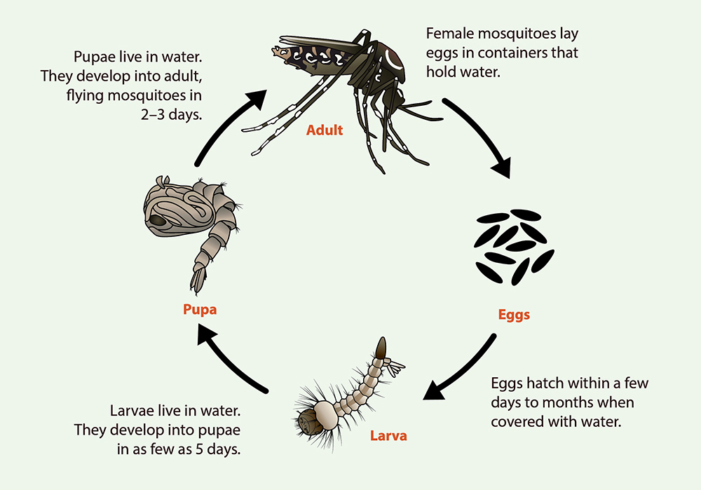

Figure 2. The life cycle of a Aedes aegypti and Ae. albopictus mosquitoes. Illustration available via the CDC at https://www.cdc.gov/mosquitoes/about/life-cycles/aedes.html

The most common genera of mosquitoes are Aedes, Culex, and Anopheles. The Centers for Disease Control and Prevention (CDC) specifically tracks the ranges of Aedes aegypti and Aedes albopictus (the mosquitoes that transmit chikungunya, dengue, Zika and yellow fever) annually to represent the likelihood of the mosquitoes being able to survive and reproduce if introduced into the environment during the season in which they are active. In addition, many public health departments and mosquito commissions track the occurrence of mosquitoes and mosquito-borne diseases throughout local municipalities.

You can study the mosquitoes in your community by building a simple arthropod trap. When researching traps, first determine the preferred life stage. Some traps will attract adults, also termed imago, whereas others are designed to collect egg rafts.

Brown Sugar & Yeast Trap

Contributed by Alex Shen, Vanderbilt University

This trap uses carbon dioxide produced from a sugar and
yeast reaction to attract and collect mosquitoes.

MATERIALS

- Empty 2L soda bottle
- Scissors or box cutter
- 1 cup (~ 250 g) brown sugar
- 4 cups warm water, divided
- 1 packet (or 1 tbsp) dry yeast
- Nitrile gloves
- Sieve or mesh strainer

METHODS
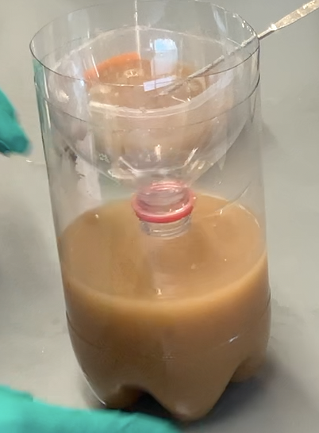
- Cut off the top 1/3 portion of the 2-liter bottle and set aside
- In the bottom 2/3 piece of the bottle, dissolve 1 cup of brown sugar in about 2 cups of warm water
- Mix the dry yeast into the warm sugar water.
- Slowly add small portions of the remaining water, swirling to mix the yeast. Avoid creating large chunks with each addition. This should form a homogeneous yeast-sugar-water solution
- With the cap off the top 1/3 of the bottle, place it on top of the 2/3 portion of the bottle in an inverted orientation
- Set the trap in a damp area with no covering on the trap. Ideal locations will have a stale water source and open flowing air
- Leave the trap undisturbed for 1-2 days
- Collect the trap and remove the inverted top portion
- Pour contents through a mesh strainer and use forceps to remove any arthropods
Assembled Brown Sugar
& Yeast Trap
- Preserve arthropods in 95% ethanol or over-the-counter rubbing alcohol (isopropyl alcohol)

VIDEO GUIDE

Join Vanderbilt student Alex Shen as he demonstrates how to construct a brown sugar and yeast trap.

https://youtu.be/ybVJM94TzCQ
Flying Insect Trap

Contributed by Alex Shen, Vanderbilt University

This trap uses the aroma from bananas and vinegar to attract and collect
mosquitoes, flies, and predatory social wasps.

MATERIALS

- Plastic container, such as 2L soda bottle or plastic milk jug
- 1 cup (~ 250 g) brown sugar
- 2 banana peels
- 1 cup (~250 mL) vinegar
- 2 cups (~ 500 mL) warm water
- 1 meter string
- Scissors or box cutter
- Sieve or mesh strainer
- Nitrile gloves
- Forceps
- 95% ethanol or rubbing alcohol

METHODS
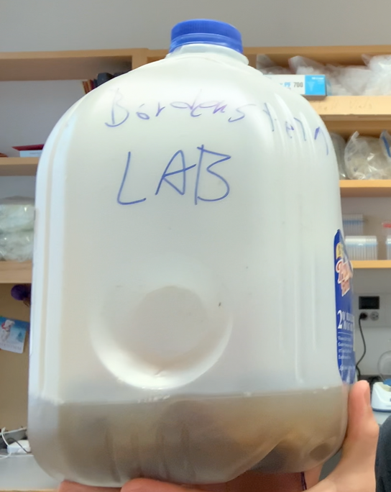
- Open the plastic container
- Carefully pour 1 cup of sugar into the container
- Cut the banana peels into strips and place into the container
- Pour 1 cup of vinegar into the container
- Pour 2 cups of warm water into the container
- Close the container with the original cap and shake thoroughly for 1 minute
- Create a handle by tying the bottleneck with the string
- Remove the cap and place the trap on the ground at a location where mosquitoes are most active (preferably in a damp environment with stale water and open airflow) or hang from a low tree branch
- Leave the trap undisturbed for 1-2 days
- Collect the trap and carefully remove the top of the container with a box cutter
Assembled Flying Insect Trap
- Pour contents through a mesh strainer and use forceps to remove any arthropods
- Preserve arthropods in 95% ethanol or over-the-counter rubbing alcohol (isopropyl alcohol)

VIDEO GUIDE

Join Vanderbilt student Alex Shen as he demonstrates how to construct a flying insect trap.

https://youtu.be/ZBAc8xUaSi4

