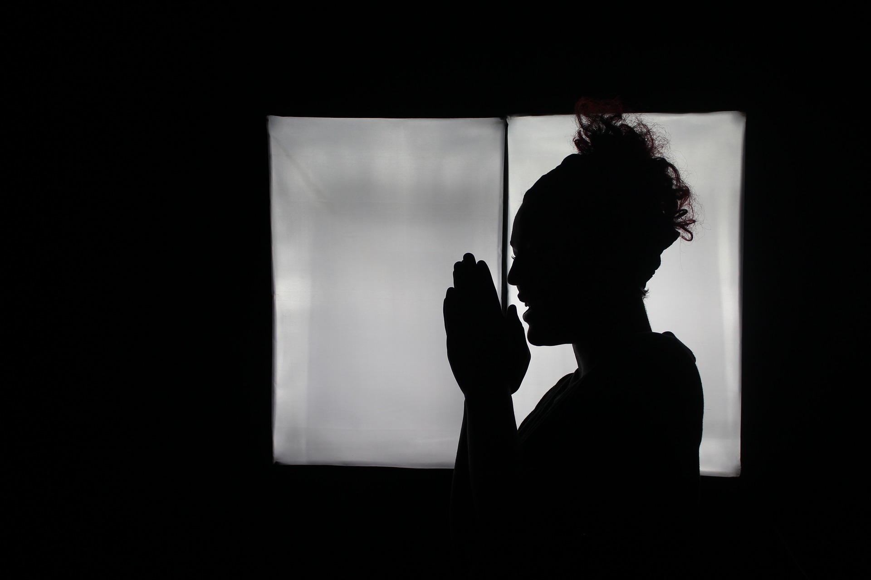

Let’s Talk Religion — How Prayer Camps Address the Mental Healthcare Shortage
By: Ashley Hill and Sabirah Oniyangi

You can’t discuss African countries without hitting on the topic of religion. Religion is embedded into almost every facet of life — from laws to curriculum, and everything in-between. This is partly a remnant of colonial times where majority of institutions, especially schools, were religiously inclined. It’s been many years post-colonialism for many countries, yet only a few African countries, particularly those in East and West Africa, show signs of becoming less religious.

It is important to know that religion serves a purpose. Dr. Harold G. Koenig, director of the Center for Spirituality, Theology and Health at Duke University Medical Center, found that more religious people had fewer depressive symptoms. "People who are more involved in religious practices and who are more religiously committed seem to cope better with stress," Koenig said. "One of the reasons is because [religion] gives people a sense of purpose and meaning in life, and that helps them to make sense of negative things that happen to them," Koenig said.

While many of the studies on religion and mental health have been done in the United States, it is clear that there does seem to be a correlation. But this only occurs when people view their God and religious practices and peaceful, benevolent and all-forgiving. There can be a dark side to it as well — where religion can be used to perpetuate harmful practices, and cause feelings of worthlessness and overall poor mental health. Religion is certainly not a replacement for mental health services, but it can be used in lieu of such services when they are not available. It is just as important to note that religion can also become a very dangerous tool in the absence of adequate facilities.

The Intersection of Religion & Mental Health
Africa is classified as the most economically disadvantaged region in the world, mainly for reasons of foreign exploitation. This mirrors the mental healthcare system across most of the continent as well. Collectively, Africa’s rate of visits to mental health outpatient facilities is 14 per 100,000 people, compared to the global rate of 1,051 per 100,000 people. If those numbers don’t alarm you, let’s zone in on a country: Ghana’s mental health sector has only 16 psychiatrists and 3 psychiatric hospitals nationwide, reflecting 1 psychiatrist per 1.5 million people. With numbers like these, and no other means of assistance in sight, it can be understood why religious institutions stepped in.

Over the past few months there have been raids on Koranic schools in Northern Nigeria. The BBC uncovered privately run Koranic and rehabilitation boarding schools where students were being kept in the most inhumane conditions. The BBC called them torture houses. Students were living in inhospitable conditions, chained, often beaten, abused and raped by their teachers. These students were there for a variety of reasons, some of them had been deemed “troublesome” by their families, some were suffering from addictions and others varying types of mental illnesses. Their families were made to believe they would be “cured” by receiving Koranic instruction. Families are often not allowed contact with their children and relatives and when they were, it was often supervised. Police have rescued over 400 students from such places in the past 6 months. After the raids many families claimed not to know about the abuse and the conditions that the students were placed in.

These types of centers are not relegated to one religious group. Just this month in Lagos, Nigeria’s bustling metropolitan city, another such prayer house was uncovered. This time a man claiming to be a Christain prophet had over 15 people chained in his premises. The victims varied in age from 19 to 50, and consisted of women and men. No area seems to be immune from these prayer houses and it is likely that with more awareness, even more of these illegal rehabilitation centers will be uncovered.

The Flip Side
As these horrendous facilities continue to be uncovered, we must begin to question why religion is being used to perpetuate such harm, and what need it is meeting in society. Earlier last year, there was an exposé on drug use in Northern Nigeria. Over 3 million people were found to be addicted to drugs, the primary gateway drug being the abuse of codeine. These facts are not unrelated. It should come as no surprise that when a country lacks adequate mental health care facilities, families will turn to desperate measures. Lack of preventative care, drug awareness and general desolation have severe impacts on mental health. Many of the families who turn to such facilities have been failed by public services and cannot afford the expensive private care, and thus turn to these prayer camps and religious rehabilitation centers.

Despite the undisputed evidence of human rights violations by way of religious prayer camps, what if there was a way to find a humane middle ground between religious sects, prayer camps, and the mental health community? This is a topic that is already being explored in Ghana, and studies show that such partnerships can be beneficial when there is mutual respect and bilateral understanding. If relationships between these two communities were to merge, it is suggested that both biomedical treatment and religious support to combat mental health be implemented simultaneously as a means of compromise. However, for those who have access, hospitals may also be a better choice of environment for those suffering with mental health issues, as religious services, accommodations for religious beliefs, and treatment all occur in one facility. The merciless practices of some prayer camps are not indicative, nor condoned, by all prayer facilities. Instead, the poor conditions, including chaining, are said to be because of limited resources. Whether this is true or not — you be the judge.

We continue to pose the questions, why is religion being used to perpetuate harm, why does public health services not include adequate mental health support? The recognition of traditional and religious beliefs and practices are important, but not at the expense of human life or marginalization.

