User Guide for
Scour Factor Calculation and Monetary Damage Estimate

Introduction

Bridges are important conduits for the transportation of goods, services and people. When bridges are damaged both direct costs to the structure and indirect costs from increased commute time, increased gas expenses, or delays in moving goods to and from market are incurred. A significant risk to the structural life of a bridge is scour. Scour occurs from water moving in and around the bridge components, like piers and abutments, resulting in the removal of bed material. Scour can undermine components and shorten a bridge’s useful life or lead to catastrophic failure. In recent years, the United States has experienced heavier rainfall and severe flooding, factors that increases bridge scour. This methodology was developed to assist communities in assessing bridge scour risk from future floods and prioritizing which bridges may require protective measures. The method is provided only as a tool and should not be used for budgeting or forecasting activities.

Requirements

This scour prediction methodology was developed using HAZUS-MH 2.1 (or Hazus) and ArcGIS, Version 10, Service Pack 2. Hazus is available for download from the United States Federal Emergency Management Agency. Other flood modeling tools may be used to provide the data for this methodology but the predictive ability has not been evaluated. The user assumes all liability for the application of this method and any decisions based on the results. No warranty, expressed or implied, is given.

Overview of Damage Prediction

Once the bridges for adaptation have been identified, the first step is to calculate the estimated replacement value. This is done by using the National Bridge Inventory to find the bridges overall length and width, in meters (fields 49 and 52). These are multiplied together then by $1803 (in 2012 dollars) to estimate bridge replacement cost. Once this has been calculated, the bridges can be ranked in order for prioritization. For bridges that are within $300,000 to $400,000 of each other in replacement cost, the following scour factor method may be used to refine the ranking.

The instructions that follow utilize Hazus to create flood models. Once the models are complete, data is gathered from the models, and other sources, and entered into the Scour Calculator. Results from the Scour Calculator are used to calculate the scour factor and monetary damage. The following scenario illustrates how this methodology may be used.

A community has several bridges each designed to withstand a 100-year flood. Community members are concerned that 450-year floods may become more common. Each area with a bridge has formed a group to lobby for their bridge being protected first. The town treasury has limited money which prevents all of the bridges from being protected this year. How do the leaders of the town determine which bridge to protect first? Utilizing Hazus and the Scour Calculator, the community can develop semi-quantitative information to use in addressing the community’s concerns.

Bridge Diagram

The following provides a reference to assist in identifying measurement locations and bridge components. It is referenced as “bridge diagram” throughout this guide.

Parapet
A
B
D
C
E
F
G

Label | Description
A | Contraction Width
B | Height of bridge bottom from stream bed
C | Pier
D | Abutment
E | Parapet Height
F | Deck Height
G | Channel Width

Flood Model

Two flood models will be required from Hazus. The first is the model for the bridges’ design flood. Using our scenario from above, this would be a flood model with a 100-year return period. To determine the design flood for a bridge, consult engineering documents from the bridge’s construction or historical records for prevailing standards at the time of construction. The second model needed is for the future flood event. Again using the scenario above, the future flood would be a model with a 450-year return period. When modeling a flood with Hazus use the highest resolution DEM available. This will improve the program’s ability to identify streams and determine flooding. Once the base and future flood models are complete data for the scour estimation entered in the Scour Calculator.

Scour Calculator – Overview

The Scour Calculator is written using Microsoft Access and Visual Basic for Applications (VBA). It is used to estimate the amount of scour at piers, abutments and bridge contractions. No programing or complex calculations are required for use. Using Hazus and other information sources, the user gathers data on the streams and bridges of interest and enters the data in the program. Once entered, the program performs all required calculations. The main screen provides the interface for data entry. The following illustration shows the main areas of the screen:

- Scenario Number – The Scenario Number is assigned by the system and serves as a record number. The Scenario Number is used during the analysis phase to let the program know which scenario to analyze.
- Return Period – This is the frequency of the flood that this scenario models. If it is for a 100-year flood enter “100”. A separate screen is completed for each bridge/return period combination. There will be at least two screens completed for a given analysis, one for design return period scour and one for future return period scour.
- Bridge Information – This area contains general information about the bridge
- Abutments – This area is used to enter data on the bridge abutments
- Piers – Data required for pier scour calculation.
- Stream Information – This area is used to enter information that characterizes the stream
- Analysis Button – This initiates the analysis for a given bridge and return period. When this is clicked the program will ask for the scenario number
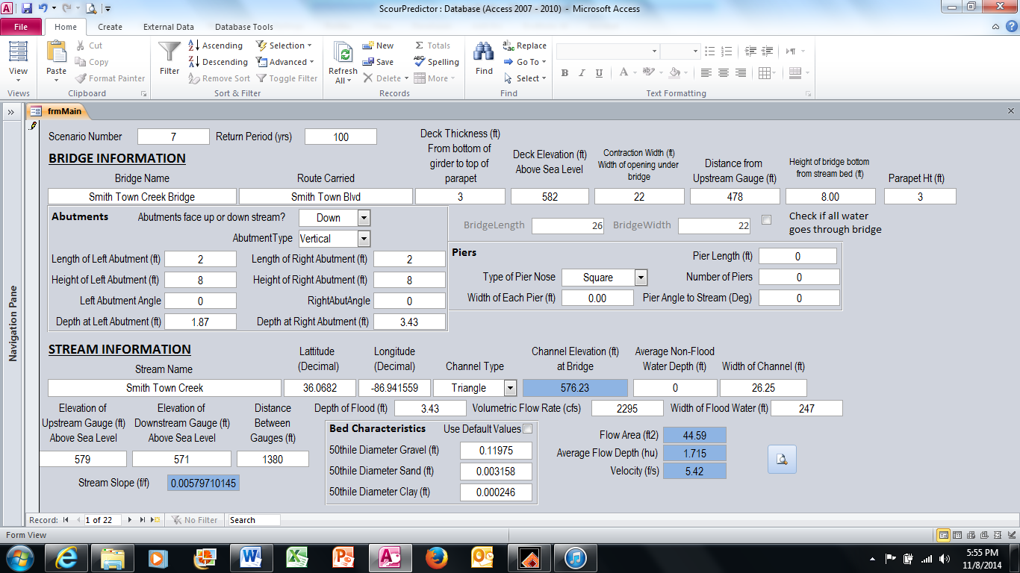
2
1
3

7
6
5
4
Bridge Information

This section identifies important measurements about the bridge. The following table provides the field name, any special requirements for the information, a description of the field, and where it may be found.

Field Name | Special Requirements | Description | Source
Bridge Name | No more than 255 characters | This may be the common name of the bridge or the name of the bridge from the National Bridge Inventory. | Community knowledge, National Bridge Inventory
Route Carried | No more than 255 characters | This is the road that the bridge carries across the stream. | Community knowledge, National Bridge Inventory
Deck Thickness | Number only | This is the thickness of the bottom of the bridge deck to the top of the parapet | Direct observation/estimation
Deck Elevation | Number only | This is the elevation above sea level of the road surface of the bridge | Google Earth estimate
Contraction Width | Number only | The width of the bridge between the abutments | Google Earth estimate
Distance from Upstream Gauge | Number only | Distance, in feet, of bridge from any upstream gauges | United States Geological Survey, distance estimate from ArcGIS or Google Earth
Parapet Height | Number only | Height of the parapet | Direct observation/estimation
Bridge Length | Number only | Total length of bridge | National Bridge Inventory, Field 49
Bridge Width | Number only | Total width of bridge | National Bridge Inventory, Field 52
Check if all water goes through bridge | N/A | This lets the program know if you want to calculate scour with all water going through the contraction. The default is unchecked | N/A

Abutments

This section identifies important measurements relative to the bridge abutments. The abutments are located at either end of the bridge where it joins the land. Label D in the bridge diagram above indicates the location of bridge abutments.

Once the type of abutment is selected, the user indicates whether the abutment faces up or down stream. If the abutment is perpendicular to the stream either value may be chosen. Selecting the type of abutment is next. The illustration below shows how each type of abutment appears when viewed from the channel or from above. Choose the one that most closely matches the bridge you are assessing.

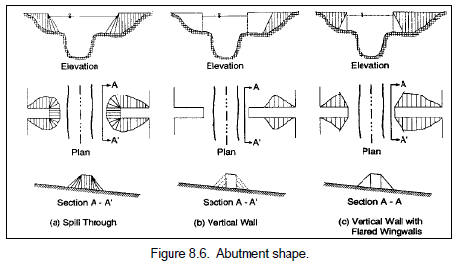
From US DOT, Hydraulic Engineering Circular 18, “Estimating Scour at Bridges”

The length and height of the abutment are required. The length of the abutment is measured from the bank to the abutment. Height is simply the distance between the top and bottom of the abutment. The following illustration shows the dimensions.

Height
Length

In some instances, there is very little embankment so the length is essentially the length of the abutment.

The angle of the abutment relative to the stream flow is required. The following illustration provides guidance on how to measure the angle. Note that it is the angle on the downstream side of the abutment.

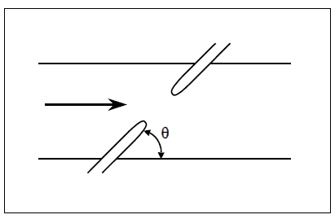
From US DOT, Hydraulic Engineering Circular 18, “Estimating Scour at Bridges”

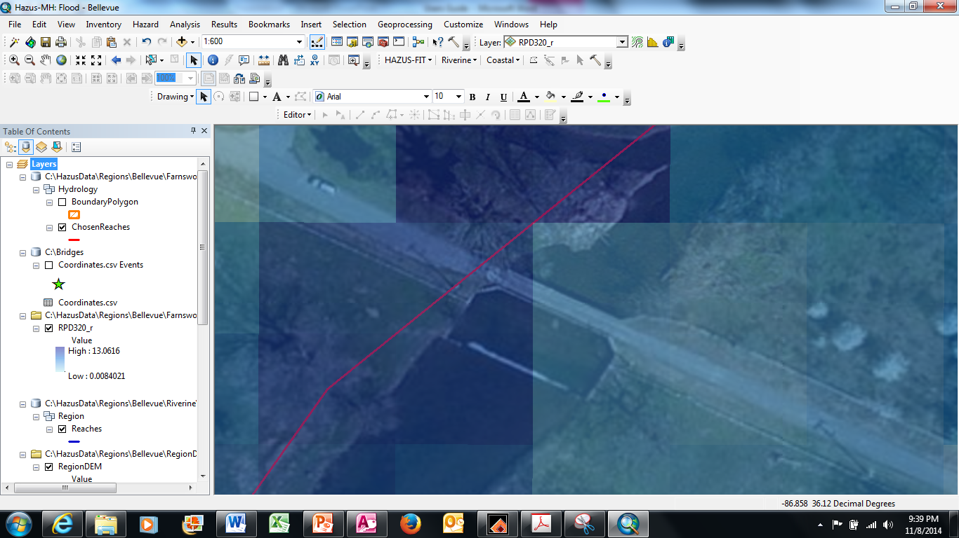
The final value needed is the depth of the flood at the abutment. To determine this, Hazus and ArcGIS are used. To make sure your measurement is in the right area, use the “Add Data” tool to add a base map to the Hazus flood model. The tool is located in the tool bar:

When prompted, select “Imagery” and select the satellite image for the area. Rearrange the Hazus layers so the flood layer is on top, followed by the streams and then the imagery layer. In the Hazus/ArcGIS “Table of Contents” window, double click the flood name to bring up the layer properties dialog box.

Once open, change transparency to 50% and click “OK”. This will allow the user to look “through” the flood to see the bridge below.

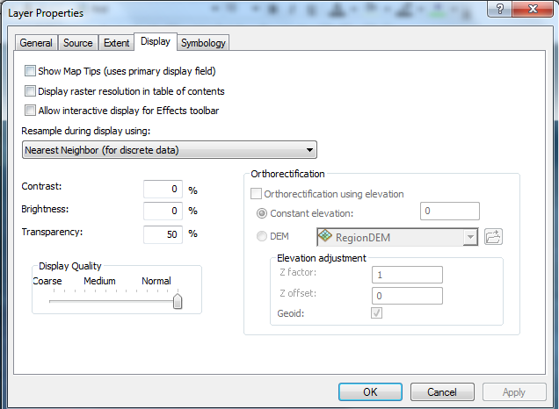

Click the “Identity” tool in Hazus/ArcGIS tool bar then click the flood over the abutment.

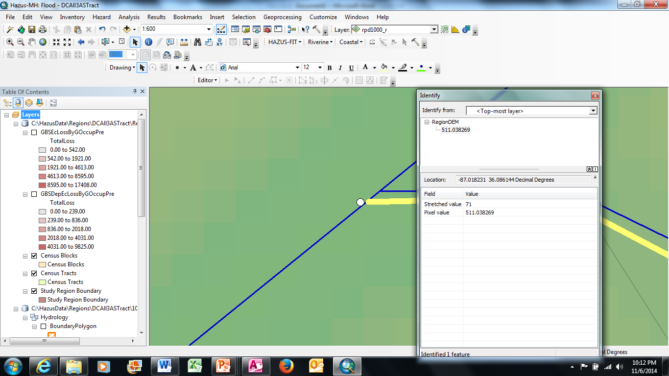

This will bring up a dialog box showing the pixel value for the clicked location. When Hazus calculates the flood it assigns each pixel of the flood layer raster the value of the flood depth, in feet. The pixel value is entered as “Depth at Abutment”. Ensure a value is obtained for each abutment, left and right.

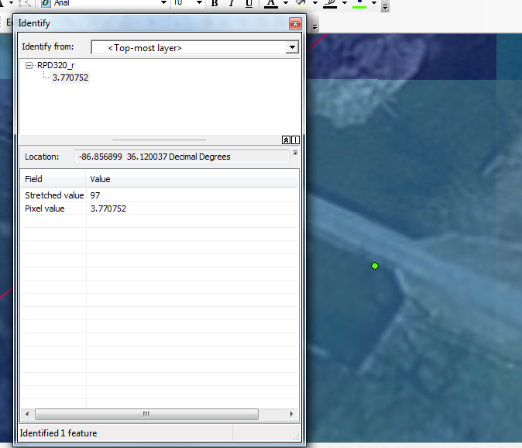

Piers

Piers are labeled “C” in the bridge diagram. In some instances, small bridges will not have piers. In these cases leave the values as “0”. For bridges with piers, first select the nose type for the pier.

The following illustration assists in selecting the nose type:

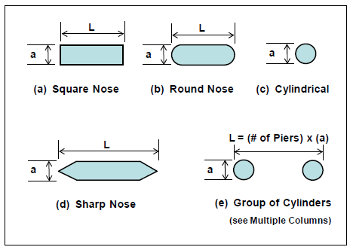
From US DOT, Hydraulic Engineering Circular 18, “Estimating Scour at Bridges”

Once the nose type is determined, measure or estimate the width of each pier (dimension “a” in the illustration) and the length of each pier (dimension “L” in the illustration).

Count the piers and enter the value in “Number of Piers”. Grouped piers count as a single pier. Finally, enter the angle of the pier relative to the stream flow. If the pier nose faces directly into the flow, the angle is “0”.

Stream Information

The remaining information pertains to the stream itself. The “Stream Name”, “Latitude” and “Longitude” fields are optional but entering them will help document the stream assessed and its location.

The “Channel Type” is used to tell the program how to calculate the cross sectional area of the stream. “Triangle” and “Trapezoid” are the options, with “Triangle” as default. All blue shaded fields are calculated by the program. These fields are locked and not editable by users.

The “Average Non-Flood Water Depth” can be found from United States Geological Survey (USGS) stream gauge data, Army Corps of Engineers data or local data. This is the average yearly depth of water in the stream at the bridge when not flooded.

“Width of Channel” is the width of the stream channel. It may also be estimated by using Google Earth® and measuring the distance between the stream banks during normal flow.

Elevation, Distances and Stream Slope

A key component of calculation is the stream slope. The stream slope is the amount a stream bed rises (or falls) over a given distance. Do not take measurements closure than 500 feet up and downriver from the bridge.

To obtain the data for entry, select two points, one above and one below the bridge. Using the ArcGIS “Line” tool, carefully trace the path of the stream between the points. The following shows the tracing in yellow and the stream in blue. Make sure the tracing follows the streambed as closely as possible. For the purposes of illustration, the tracing has been offset so the stream beneath can be seen.
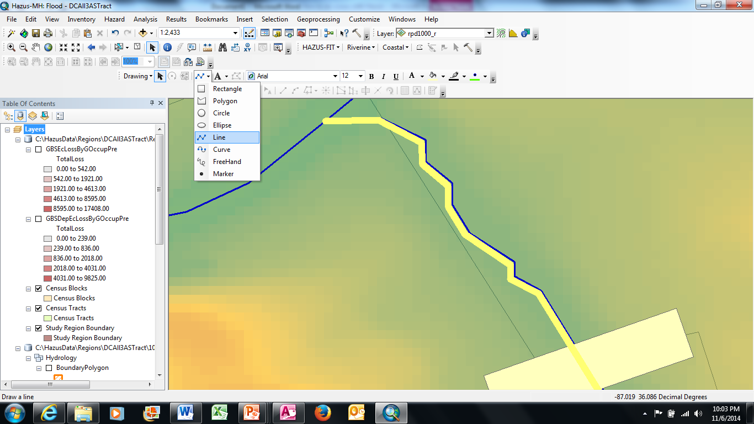
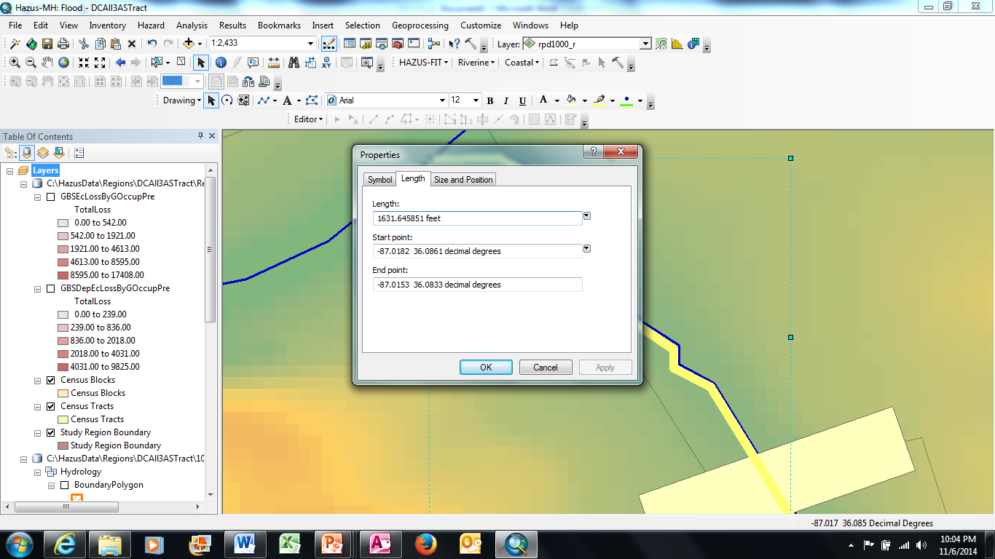

Once the stream has been traced, select the line, right click to bring up the ArcGIS sub-menu and select “Properties”. This will provide the length between the upstream and downstream points. Record this value as “Distance between Gauges”.

After the distance between the gauges is found, determine the elevations at both ends of the line. This is done using the “Identify” tool in ArcGIS to obtain the pixel value from the Digital Elevation Model (DEM). In Hazus, the pixel value from the DEM is the same as the elevation. Click the “Identify” tool (the “i”) and then click the end of the line (the white dot in the figure below provides a reference). A dialog box will appear. The number shown next to “Pixel Value” is the elevation. In this case, it is 511 feet. Repeat this process for the other end of the line.

Pixel Value (Elevation)

Record the higher number as the “Elevation of Upstream Gauge” and the lower number as “Elevation of Downstream Gauge”.

Depth of Flood and Width of Flood Water

The “Depth of Flood” and “Width of Flood Water” values are determined using Hazus. Again using the “Identify” tool, click directly in the center of the stream bed, immediately upstream from the bridge. As before, use the pixel value as the “Depth of Flood”.

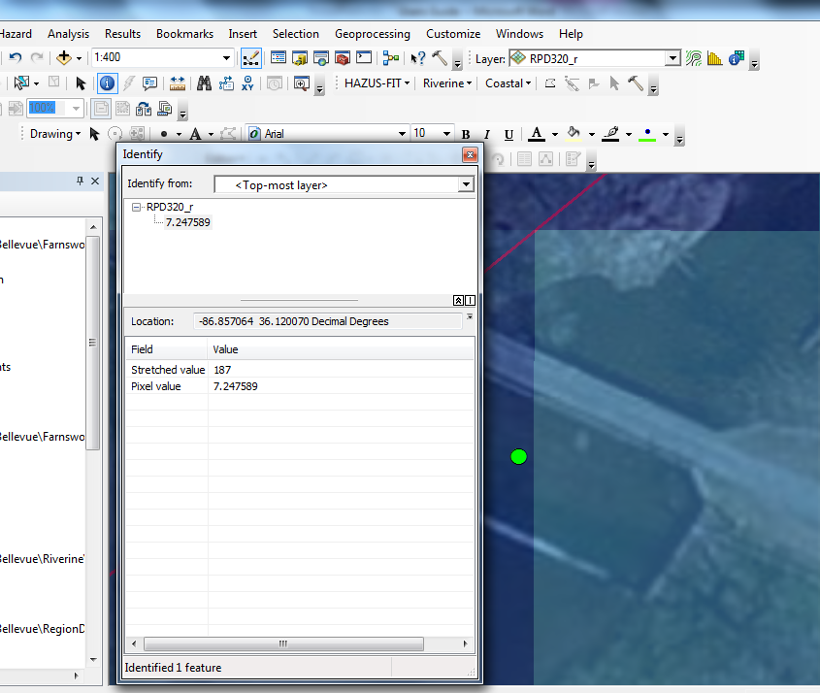

“Width of Flood Water” is determined by zooming out until the width of the flood in relation to the bridge may be seen. Using the “Line” tool, draw a line between the edges of the flood just upstream from the bridge. Once the line is drawn, select the line, right click to bring up the ArcGIS sub-menu and select “Properties”. The length will be shown in the dialog box.

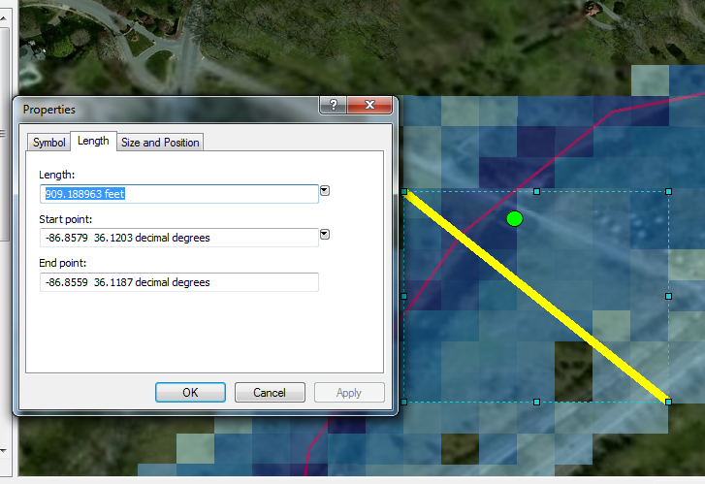
Volumetric Flow Rate

The volumetric flow rate is calculated by Hazus. The value is stored in the “FlHydraulicsLog.txt” file. Directions are required in finding the file.

When Hazus opens, the user must create a study region. This region is usually the general area in which flood studies are conducted, such as “Smith County” or “Harpeth River”. Once created, multiple scenarios may be run for a single region. Each time a scenario is created Hazus creates a scenario directory under that region name. As an example, a study region named “Harpeth Bridge” was created and under this several scenarios were modeled one of which was named “100”. To find the FlHydraulicsLog file for this scenario, the user opens Microsoft File Explorer and navigates to the directory where the Hazus regions are stored. Once there, the user would find and double click the directory called “100”. Once there, double clicking the “FlHydraulicsLog.txt” file will open the file in Windows Note Pad or similar text editor.

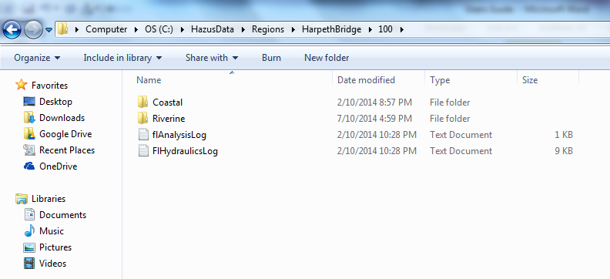

The FlHydraulicsLog file contains information on all streams assessed in the scenario. To determine the stream needed for calculation, return to Hazus and identify the stream that runs beneath the bridge of interest. Using the “Identify” tool click the stream. The dialog box that pops up will have several items but the one of interst is “ArcID”. With the ArcID identified, open the FlHydraulicsLog.txt file. The ArcID is equal to the ReachID presented in the text file. Using the text editors search or find function, search for the ArcID. Once it is found, scroll down 4-8 lines to find the discharge value.

In the example below, if ArcID 869 was the stream of interest, the volumetric flow would be 25,082 cubic feet per second (highlighted). Enter this value in “Volumetric Flow Rate”.

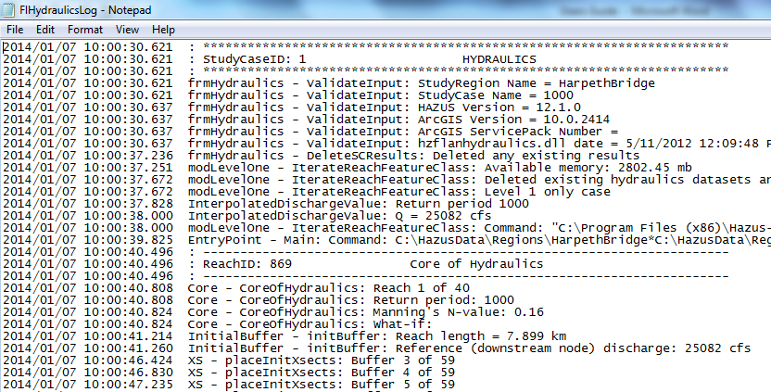

Bed Particle Size

Calculating contraction scour depends on the distribution of particle types and average diameter of the particles making up the stream bed. Since bed characterization may not be possible, the program assesses scour for the median particle size for gravel, sand and clay. If “Use Default Values” is checked pre-loaded values representing the fiftieth percentile diameter for each size range (gravel, sand and clay) will be used. If the median particle size for each type is known for a stream, leave this box unchecked and manually enter the values, in feet.

Calculating Scour

After entering all values flood scour is ready to be calculated. Note the scenario number. Click the analysis icon in the bottom right of the screen.

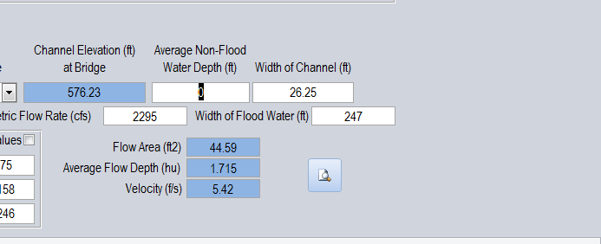

Once clicked, the program will open a dialog box. Input the Scenario Number and click “OK”. The scour for that flood return period will be calculated.

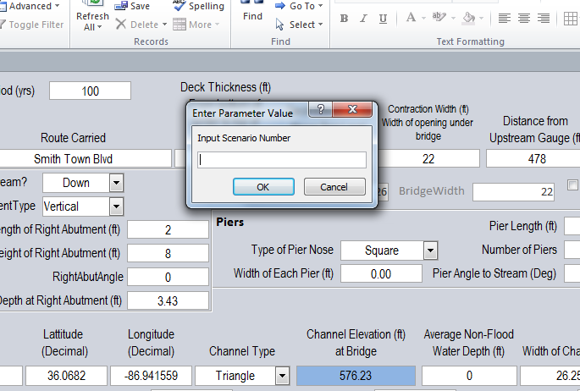

When the analysis is complete a report will be displayed.

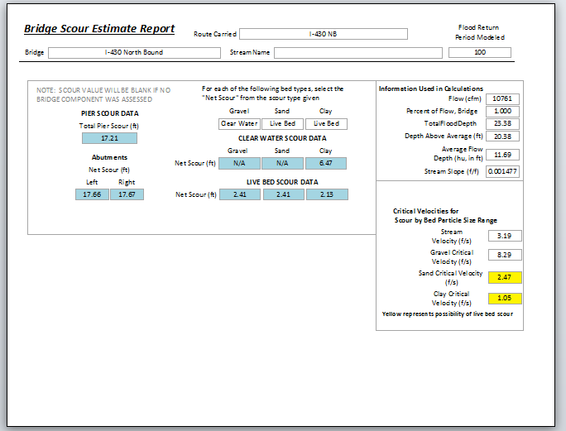
2
1

Pier and Abutment Scour are presented as single numbers. Contraction Scour requires interpretation. In area 1 note that each particle type is identified as “Clear Water” or “Live Bed”. Choose the values in area 2 based on “Clear Water” or “Live Bed” as indicated in area 1. As an example, in the above example, the value for clay in area 1 is “Live Bed”. Using this example, the value of 2.13 would be used instead of the 6.47 given for clear water.

Calculating the Scour Factor and Estimated Damage

When scour analysis is complete all that remains is estimating the monetary damage from the flood event. To perform this analysis, use the Scour Factor Workbook file for Microsoft Excel. Beginning with Base Year, enter the scour values for pier, abutment and contraction in the spaces provided. Repeat this process for the Future Year scour. The final step is to enter the bridge length and width. The workbook will automatically calculate the scour factor as well as the estimated monetary damage.

Adaptation Planning

Bridge adaptation planning should proceed from highest monetary impact value to least. This will ensure those bridges with greatest economic impact value are protected first. It is recommended that the National Cooperative Highway Research Program (NCHRP) web-only document 107 “Risk-Based Management Guidelines for Scour at Bridges with Unknown Foundations” be used in conjunction with this methodology to ensure indirect costs for bridge failure are captured. The NCHRP document and spreadsheet for calculating indirect cost is available at http://www.trb.org/Main/Public/Blurbs/157792.aspx. Using this methodology will provide estimated indirect cost due to bridge failure resulting from increased commute time, increased fuel costs and diverted commercial traffic.

Data Collection Sheet

The following may be used to assist in collecting data for scour analysis.

Stream Name
Road Carried
Flood Return Period |  | Bridge Length |  | Bridge Width

ALL UNITS ARE “FEET” UNLESS OTHERWISE NOTED

Parapet
Contraction Width
Bridge Bottom to Stream
Bed
D
C
Parapet Height
Deck Thickness
Stream Bed Width
Left Abutment |  |  | Right Abutment
Length |  |  | Length
Height |  |  | Height
Angle (degrees) |  |  | Angle (degrees)
Depth |  |  | Depth

Pier |  |  | Stream Data
Type |  |  | Average Non-Flood Depth
  Square | Round | Circular
  Grouped |  | Sharp
Type |  |  | Depth of Flood  (Center of Channel)
Width |  |  | Upstream Gauge Elevation
Length |  |  | Downstream Gauge Elevation
Number |  |  | Distance between Gauges
Angle (degrees) |  |  | Width of Flood
Flow
(cubic feet per second, cfs)

