Iowa Program-Wide Positive Behavioral Interventions and Supports (PW-PBIS)

Vision:
To promote the social, emotional and behavioral competence of Iowa’s young children, all early care and education settings in the state will provide services that embody the pyramid model of positive behavioral interventions and supports.
Mission:
The purpose of the Iowa Statewide PBIS Leadership Team is to develop a statewide, interagency system that provides ongoing training, technical assistance, coaching and implementation support to assure PBIS is well understood and being implemented with high fidelity, and that programs implementing PBIS are using data to improve services.
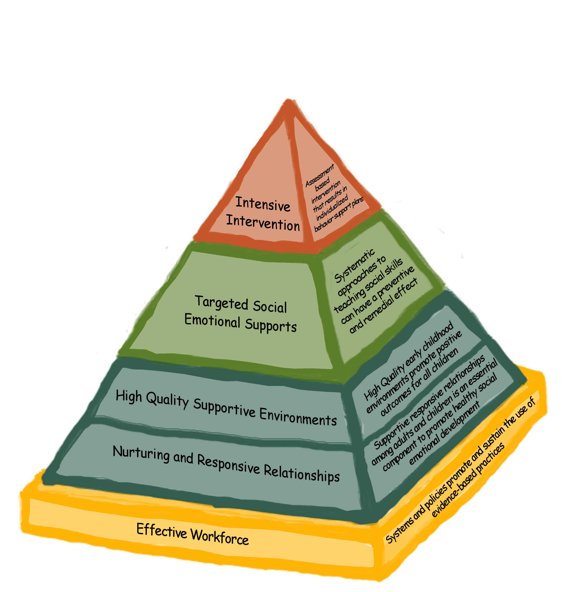
THE PYRAMID MODEL

